|  |  |  |  |  |  |
| --- | --- | --- | --- | --- | --- |
| Date | 22-Nov-22 | | | Tester Name | Richard Belanger |
| Environment | Penfax - Test | | | Login used | TEST2 |
| Operating System | Windows | Version: | Update: | | |
| Software Used | Edge | Version: | Update: | | |
| Not Applicable | Version: | Update: | | |
| Release version | 22.4.1 | | | | |
| Title | M 2.06 Edit a Marital Status | | | | |
| Test Type | Regression | | | | |
| Test Scenario | In PENFAX edit a Marital Status to a Member | | | | |
|  |  | | | | |
| Expected Results | The marital status will be edited and verified. It will then be the marital status of record | | | | |
| Pass/Fail | Pass | | | JIRA# | N/A |

Describe your steps with screenshots:

SID = 126373, Member is Married

PENFAX

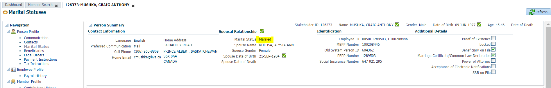

PENWEB

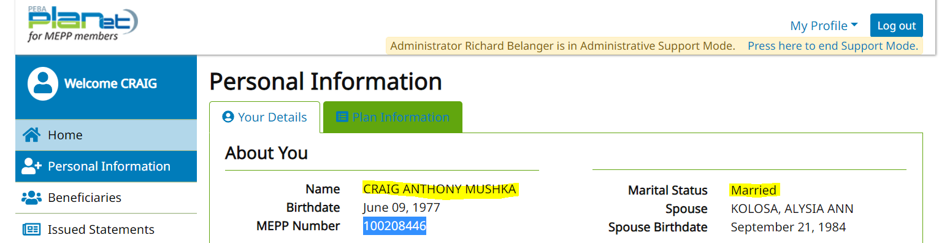

Edit Marital Status in PENFAX

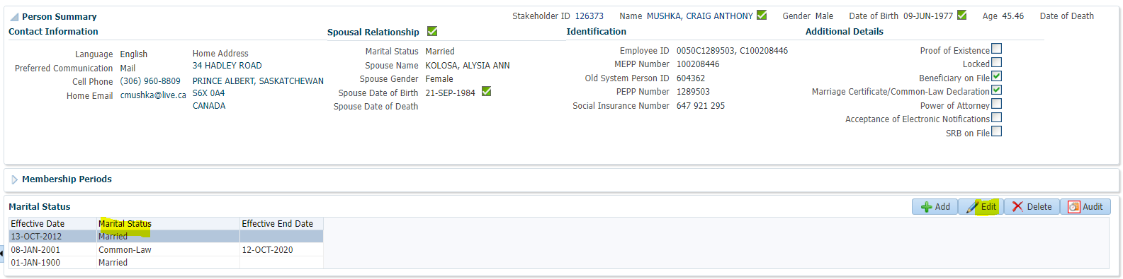

Edited in PENFAX

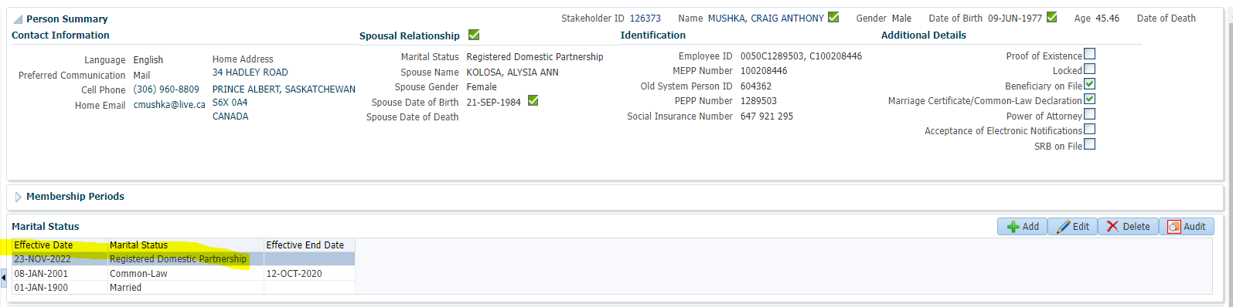

Updated in PENWEB

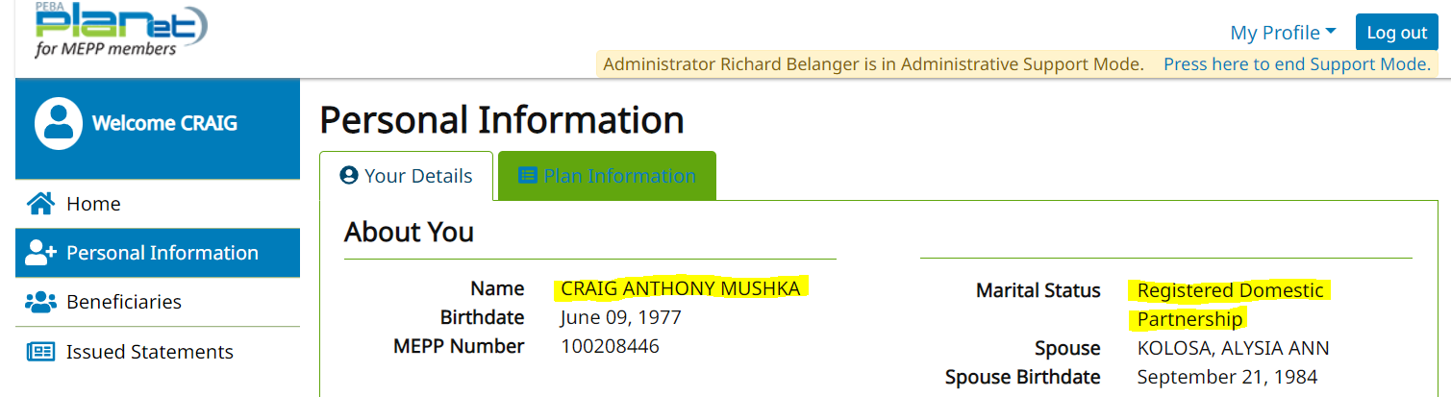

SID = 135348, Member is Married

PENFAX

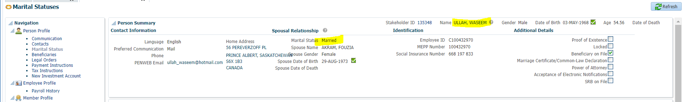

PENWEB

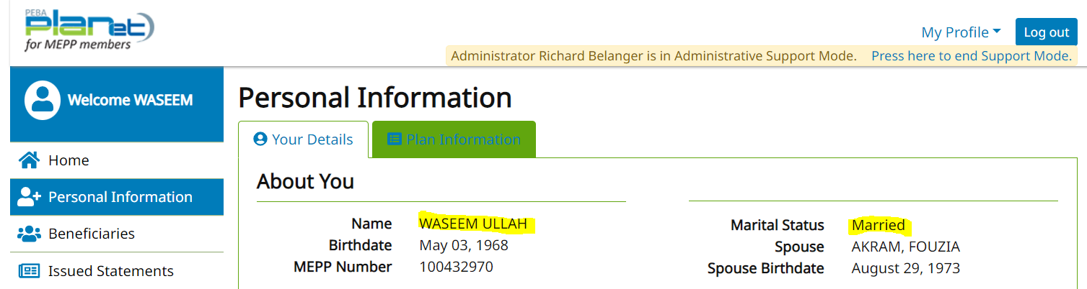

Edit to change status to Common Law

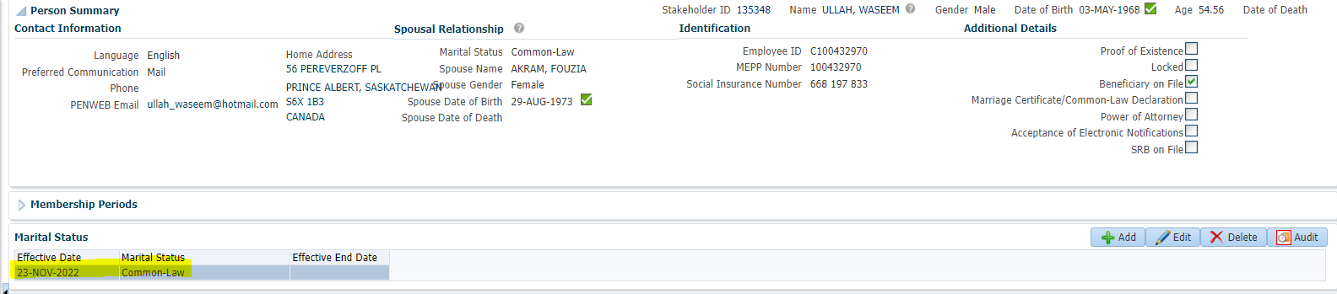

PENWEB

